Title: One-way (non-return) valve needle
Class 24
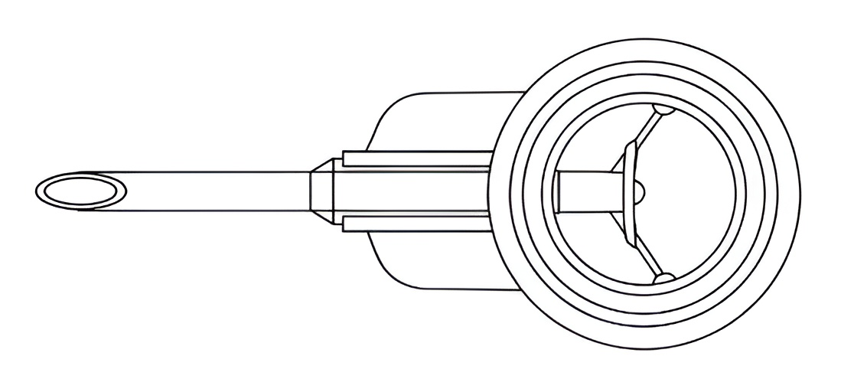Figure 1: The perspective view
Figure 1 illustrates the perspective view of the one way non return valve needle. The main objective of this design is to prevent the flow of the blood in the reverse directions. As shown in the image, the valve present inside the needle will always prevent the fluid or blood to flow in the opposite direction. Hence, it will always pass the blood in one direction only. The one way pressure responsive valve integrated inside the needle will permit the blood or the infusion fluid to move in one direction, while automatically preventing reverse flow from the vein back to the needle when the fluid inside the bottle is finished.
The originality of the proposed design lies in the self working, passive return valve inside the needle fluid pathway.

Dhananjay Patel Vinita Bhandiwad Aniket Kundu Debarati Ghosal Dhriti Dey

One-way (non-return) valve needle
Class 24

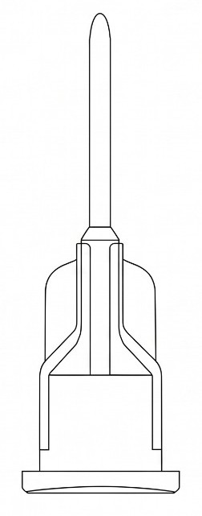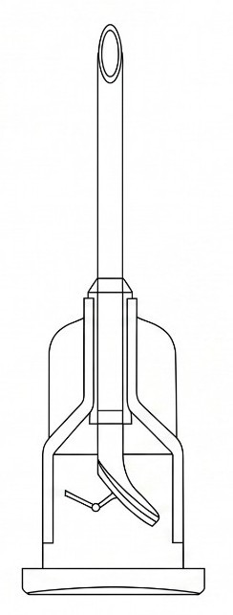
Figure 2: The Side View
As shown in Figure 2, the valve at the bottom of the needle will act as a gateway for the fluid to flow in only one direction and it will obstruct the flow in the opposite direction.

Dhananjay Patel Vinita Bhandiwad Aniket Kundu Debarati Ghosal Dhriti Dey
One-way (non-return) valve needle
Class 24

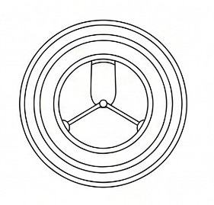
Figure 3: Top View
Figure 3 illustrates the top view of the one way non return valve needle.
To the best of our knowledge and belief, the design and concept presented in this invention are original and have been developed independently by us. We believe that the specific combination of the pressure-responsive valve flap, tether mechanism, and needle–catheter fluid pathway described herein provides a novel approach for controlling fluid flow and preventing backflow during venous access procedures.

Dhananjay Patel Vinita Bhandiwad Aniket Kundu Debarati Ghosal Dhriti Dey

